Cylinder-Based Composite Solids

Definition
# Source: AI Source: Provided by: [Data Path: Persons Table -> ID Column: 1, Name_En Column: Motasem Essam] -> From: [ChatGPT] on [7/25/2026]
Cylinder-Based Composite Solids are three-dimensional geometric objects formed by joining a cylinder with one or more other solids that have flat surfaces, curved surfaces, or both.
The resulting solid contains at least one cylindrical component and may have a combination of flat faces, circular bases, and curved lateral surfaces.
Examples include:
- A cylinder with a cone attached to its top.
- A cylinder with a hemisphere attached to one or both ends.
- A cylinder joined to a rectangular prism.
- A cylinder combined with a sphere or another cylinder.

Simple Definition
# Source: AI Source: Provided by: [Data Path: Persons Table -> ID Column: 1, Name_En Column: Motasem Essam] -> From: [ChatGPT] on [7/25/2026]
A cylinder-based composite solid is a 3D shape made by combining a cylinder with other geometric solids.
For example, attaching a cone to the top of a cylinder creates a composite solid with a cylindrical curved surface, a conical curved surface, and a flat circular base.

Geometric Representation
# Source: AI Source: Provided by: [Data Path: Persons Table -> ID Column: 1, Name_En Column: Motasem Essam] -> From: [ChatGPT] on [7/25/2026]
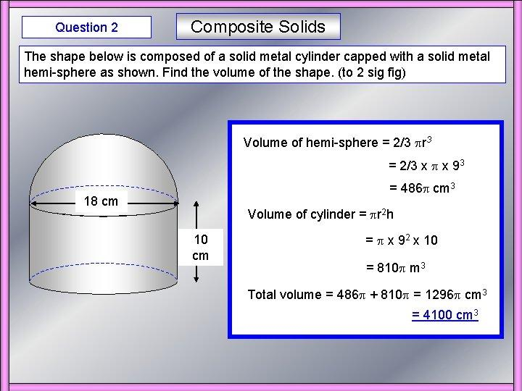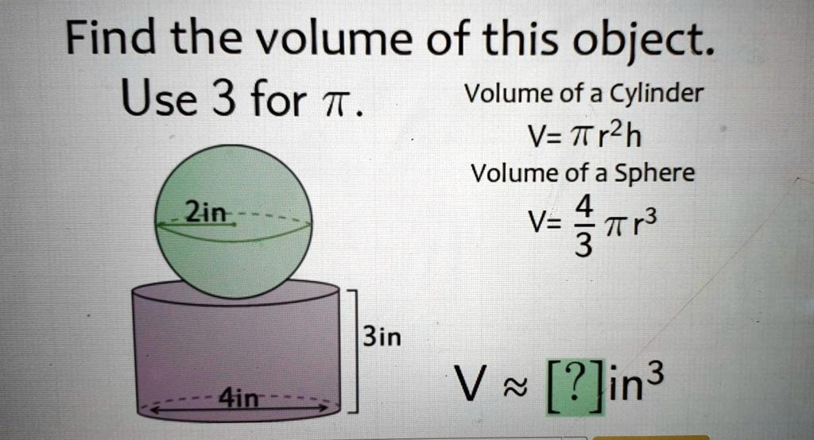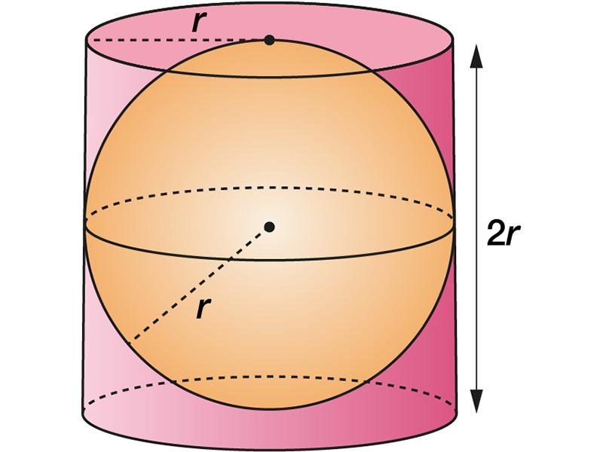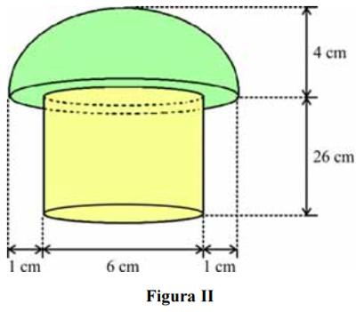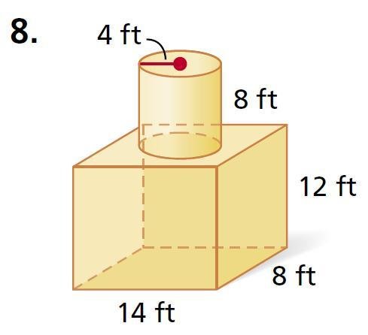
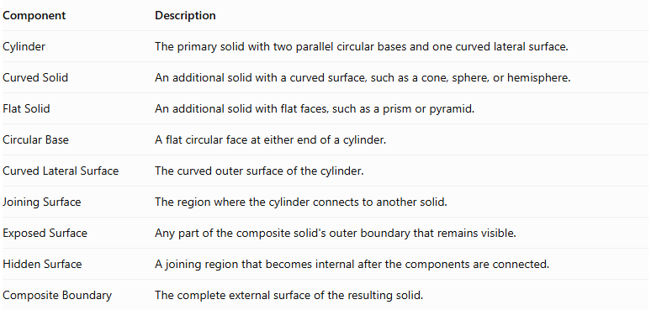
Component | Description
Cylinder | The primary solid with two parallel circular bases and one curved lateral surface.
Curved Solid | An additional solid with a curved surface, such as a cone, sphere, or hemisphere.
Flat Solid | An additional solid with flat faces, such as a prism or pyramid.
Circular Base | A flat circular face at either end of a cylinder.
Curved Lateral Surface | The curved outer surface of the cylinder.
Joining Surface | The region where the cylinder connects to another solid.
Exposed Surface | Any part of the composite solid's outer boundary that remains visible.
Hidden Surface | A joining region that becomes internal after the components are connected.
Composite Boundary | The complete external surface of the resulting solid.

Types of Cylinder-Based Composite Solids

Cylinder-Cone Composite Solids
# Source: AI Source: Provided by: [Data Path: Persons Table -> ID Column: 1, Name_En Column: Motasem Essam] -> From: [ChatGPT] on [7/25/2026]
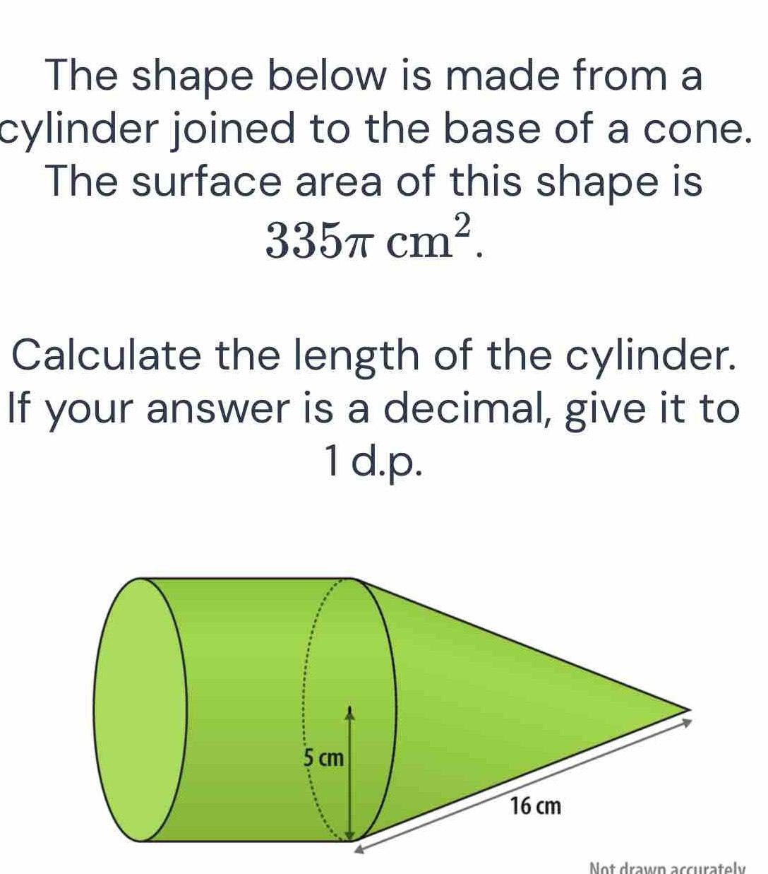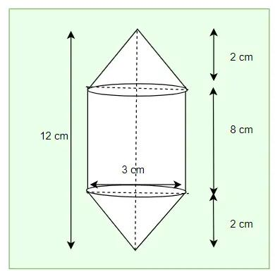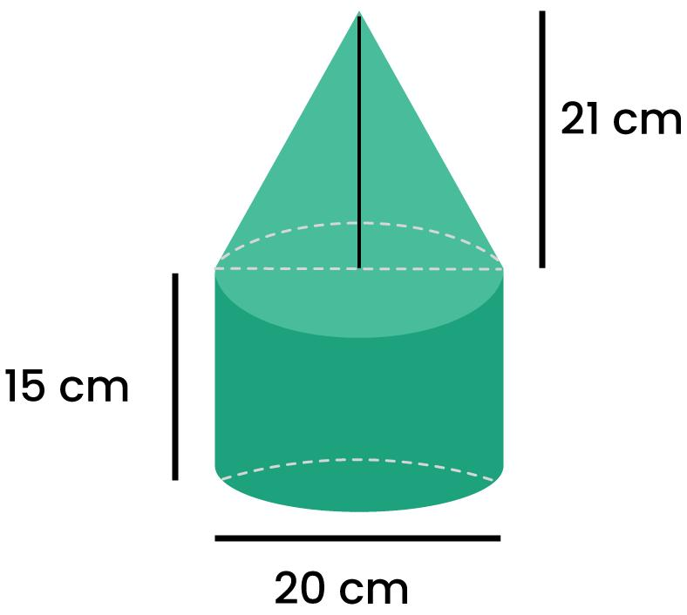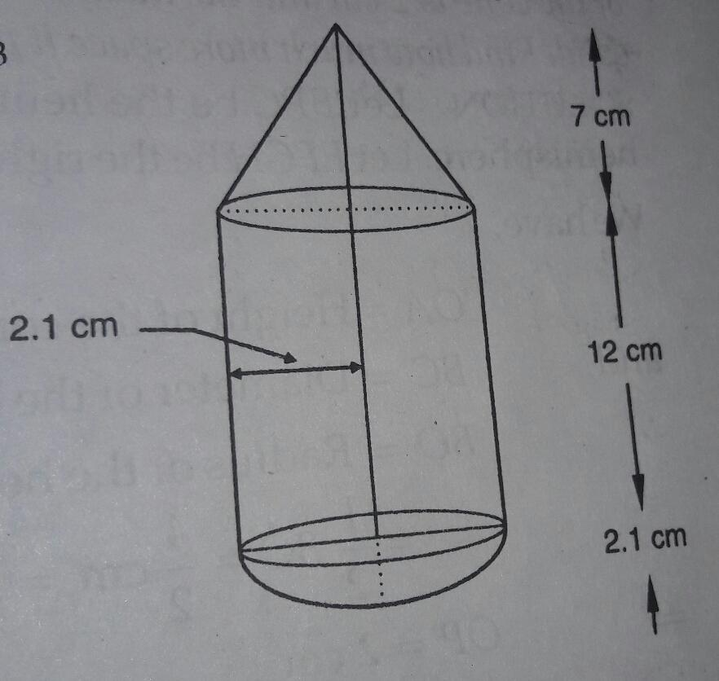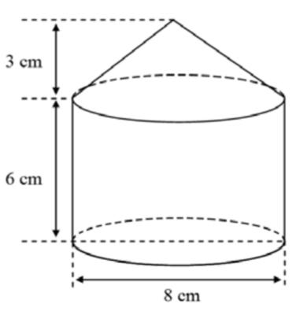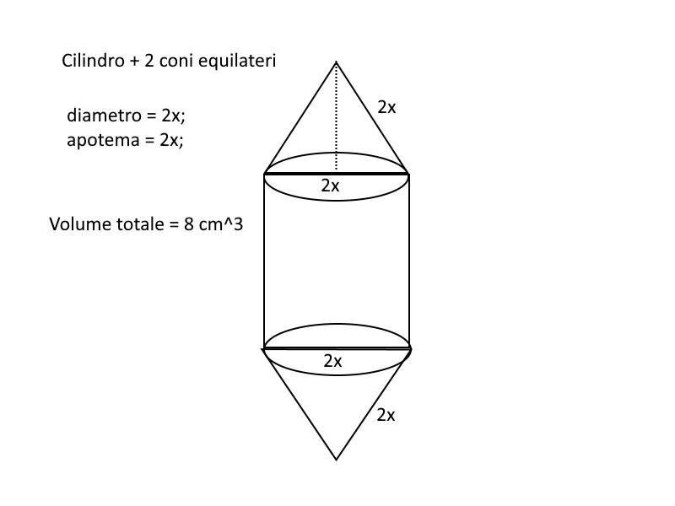
Formed by joining one or more cones to a cylinder.
Examples:
- Cylinder with a cone on top.
- Cylinder with a cone underneath.
- Cylinder with cones attached to both ends.
- Cylinder with multiple cones.
- Cylinder with a cone attached to its side.

Cylinder-Sphere Composite Solids
# Source: AI Source: Provided by: [Data Path: Persons Table -> ID Column: 1, Name_En Column: Motasem Essam] -> From: [ChatGPT] on [7/25/2026]
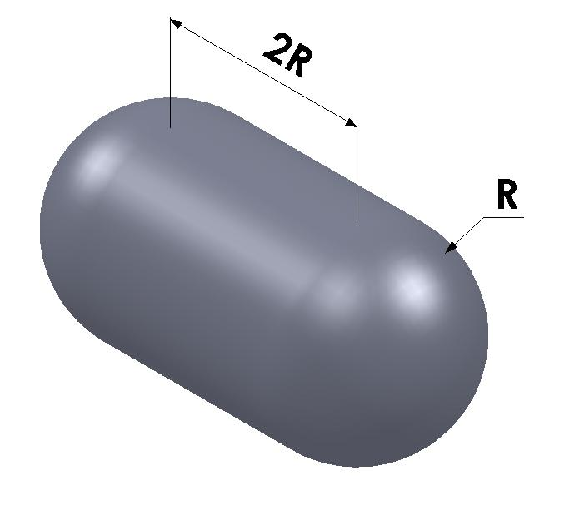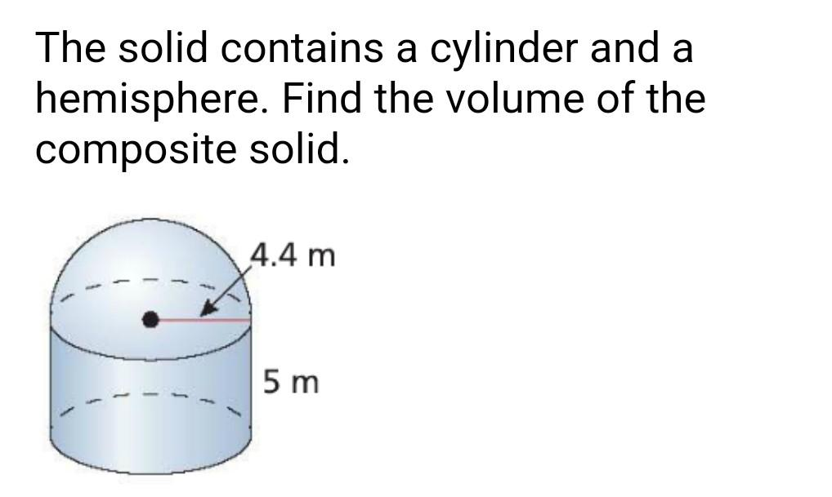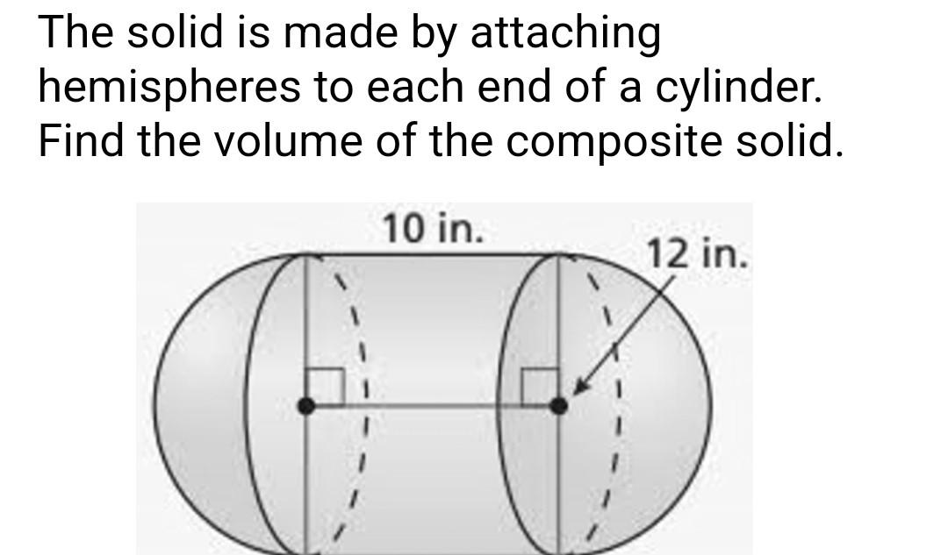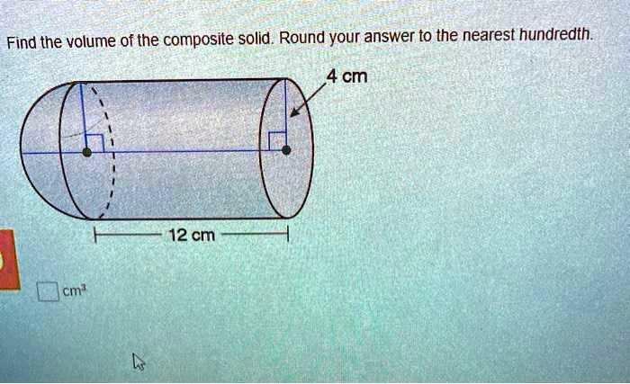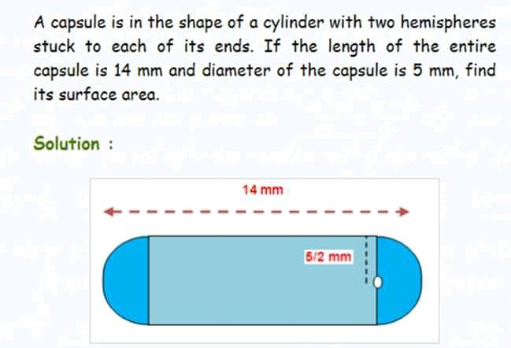
Formed by combining a cylinder with one or more spheres.
Examples:
- Cylinder with a sphere attached to one end.
- Cylinder with a sphere attached to its side.
- Cylinder with multiple spheres.
- Cylinder with spherical components arranged symmetrically.

Cylinder-Hemisphere Composite Solids
# Source: AI Source: Provided by: [Data Path: Persons Table -> ID Column: 1, Name_En Column: Motasem Essam] -> From: [ChatGPT] on [7/25/2026]
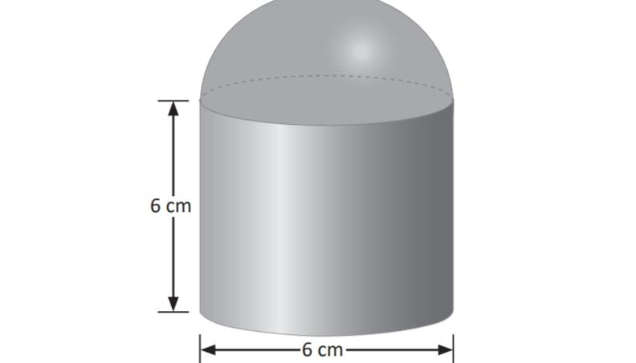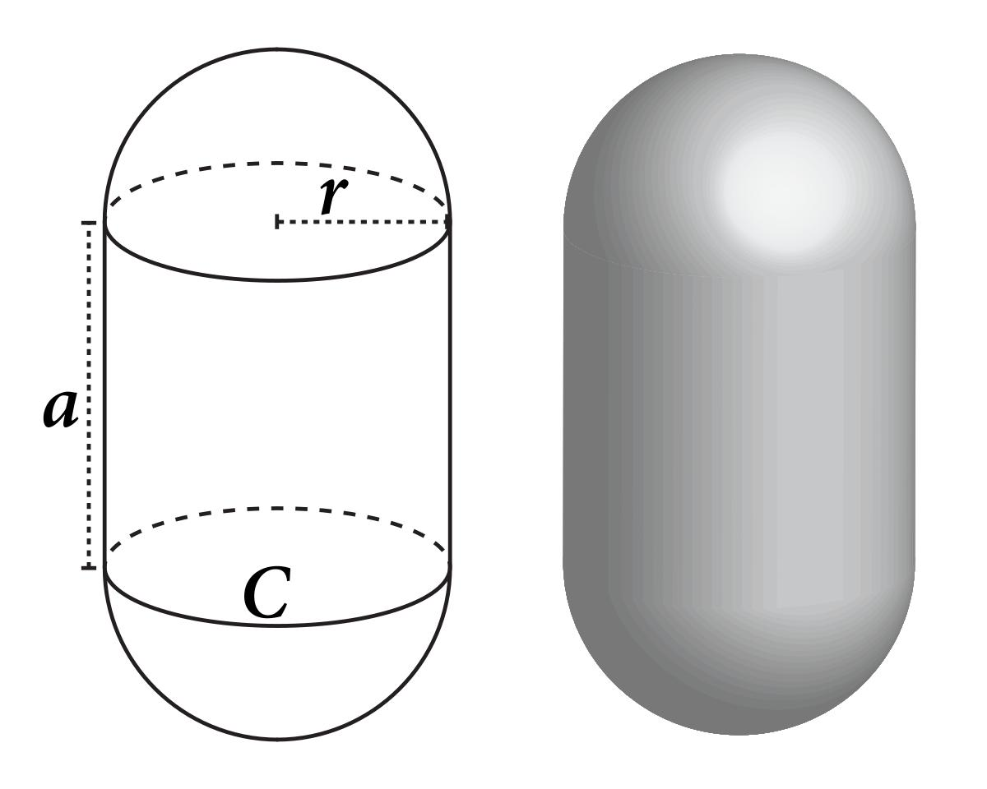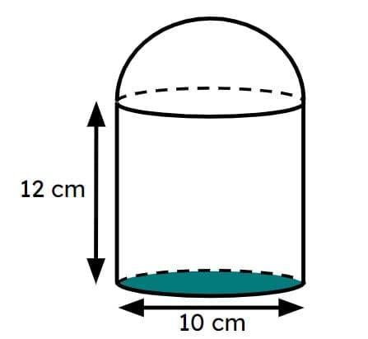
Formed by joining a cylinder with one or more hemispheres.
Examples:
- Cylinder with a hemisphere on top.
- Cylinder with a hemisphere underneath.
- Cylinder with hemispheres at both ends.
- Cylinder with multiple hemispherical components.

Cylinder-Frustum Composite Solids
# Source: AI Source: Provided by: [Data Path: Persons Table -> ID Column: 1, Name_En Column: Motasem Essam] -> From: [ChatGPT] on [7/25/2026]
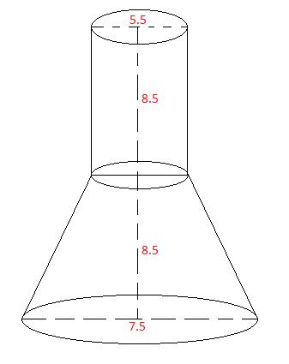
Formed by combining a cylinder with one or more frustums.
Examples:
- Cylinder with a conical frustum on top.
- Cylinder with a frustum underneath.
- Cylinder with frustums at both ends.
- Cylinder with multiple frustums.

Cylinder-Prism Composite Solids
# Source: AI Source: Provided by: [Data Path: Persons Table -> ID Column: 1, Name_En Column: Motasem Essam] -> From: [ChatGPT] on [7/25/2026]
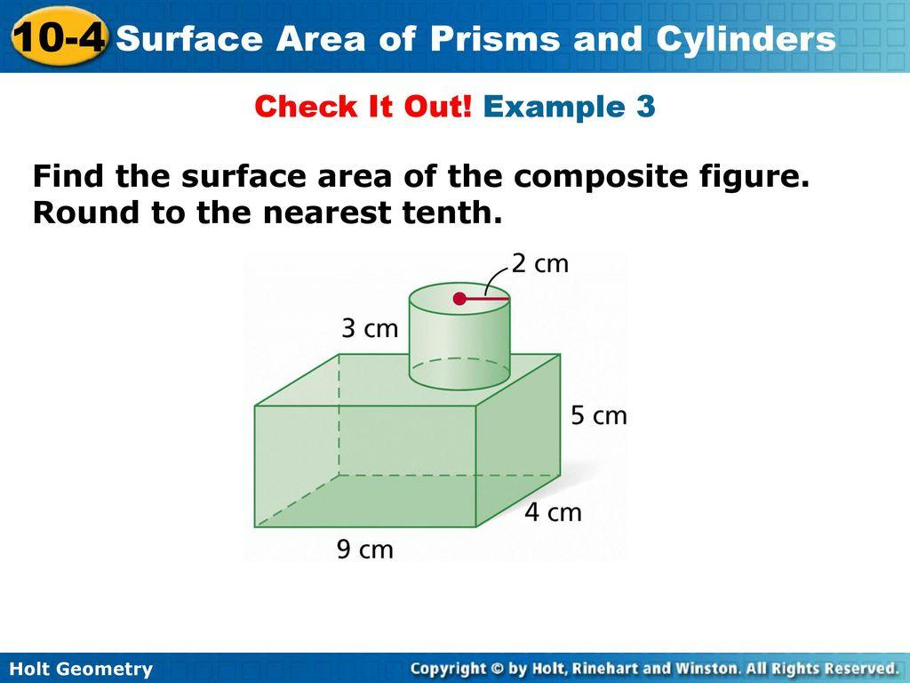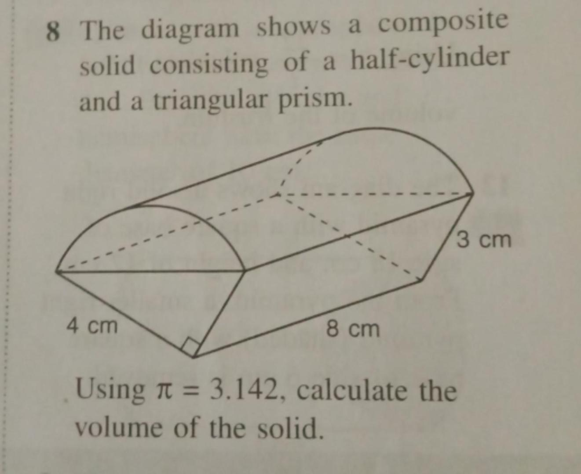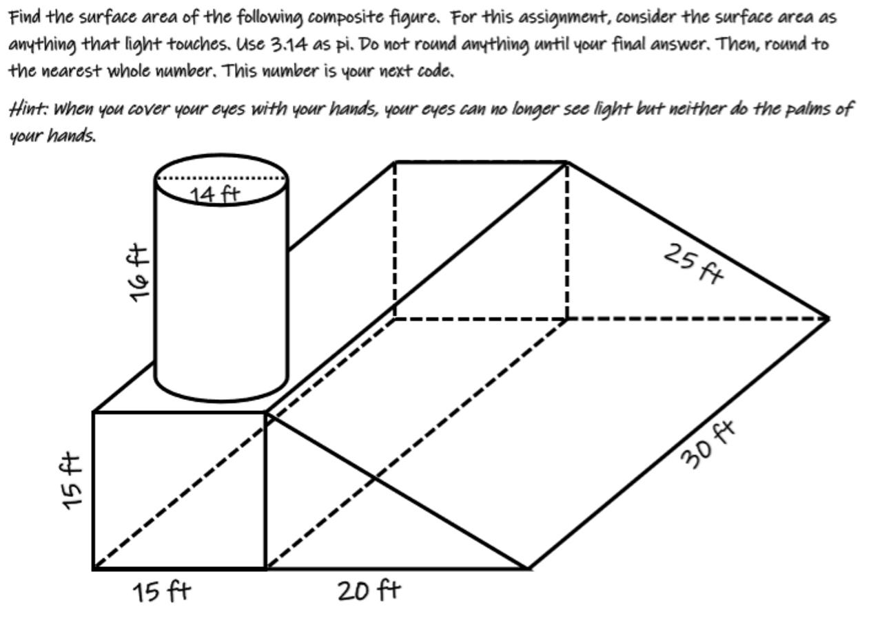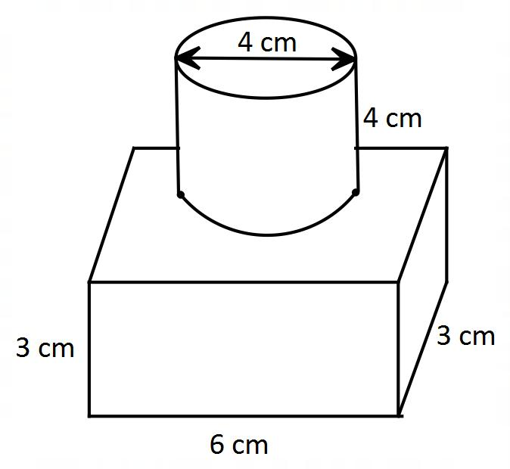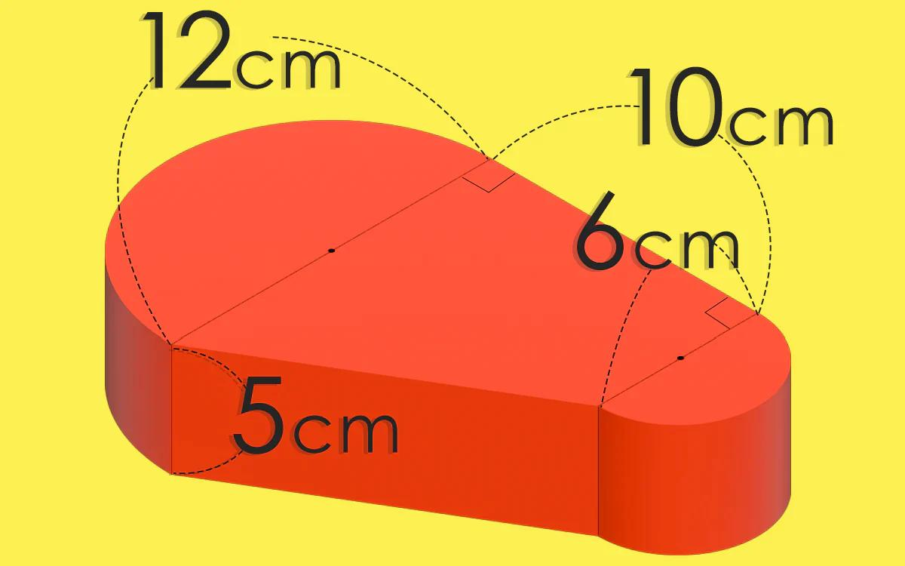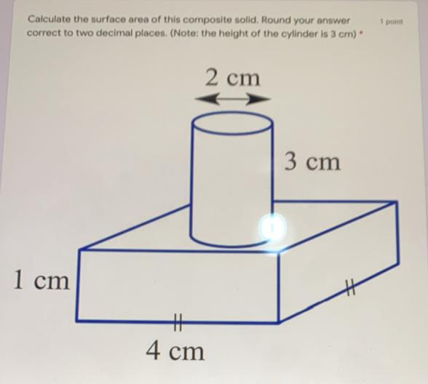
Formed by joining a cylinder with a prism.
Examples:
- Cylinder with a rectangular prism.
- Cylinder with a triangular prism.
- Cylinder with a square prism.
- Cylinder with multiple prisms.
- Cylinder attached to a prism's side or end.

Cylinder-Pyramid Composite Solids
# Source: AI Source: Provided by: [Data Path: Persons Table -> ID Column: 1, Name_En Column: Motasem Essam] -> From: [ChatGPT] on [7/25/2026]
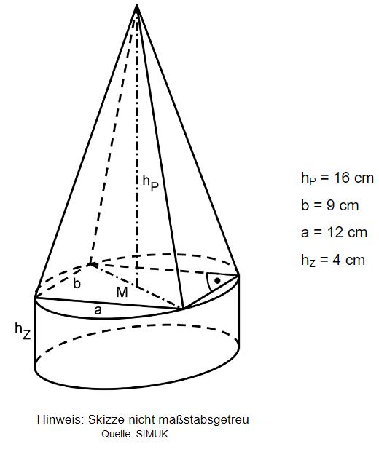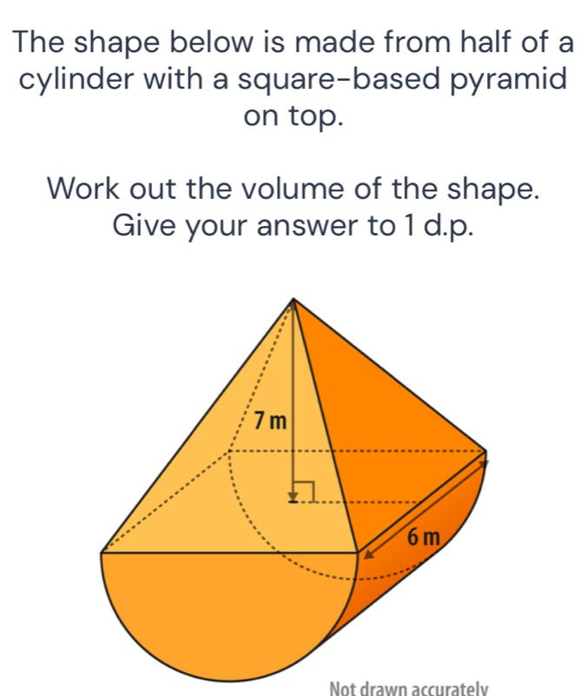
Formed by combining a cylinder with one or more pyramids.
Examples:
- Cylinder with a square pyramid on top.
- Cylinder with a triangular pyramid attached.
- Cylinder with a pyramid underneath.
- Cylinder with multiple pyramids.

Cylinder with Multiple Curved-Solid Types
# Source: AI Source: Provided by: [Data Path: Persons Table -> ID Column: 1, Name_En Column: Motasem Essam] -> From: [ChatGPT] on [7/25/2026]
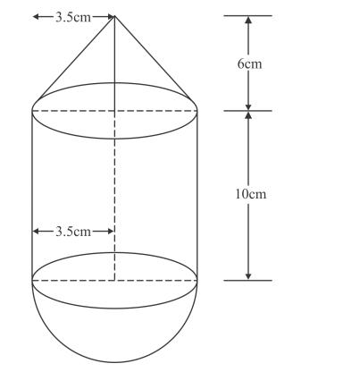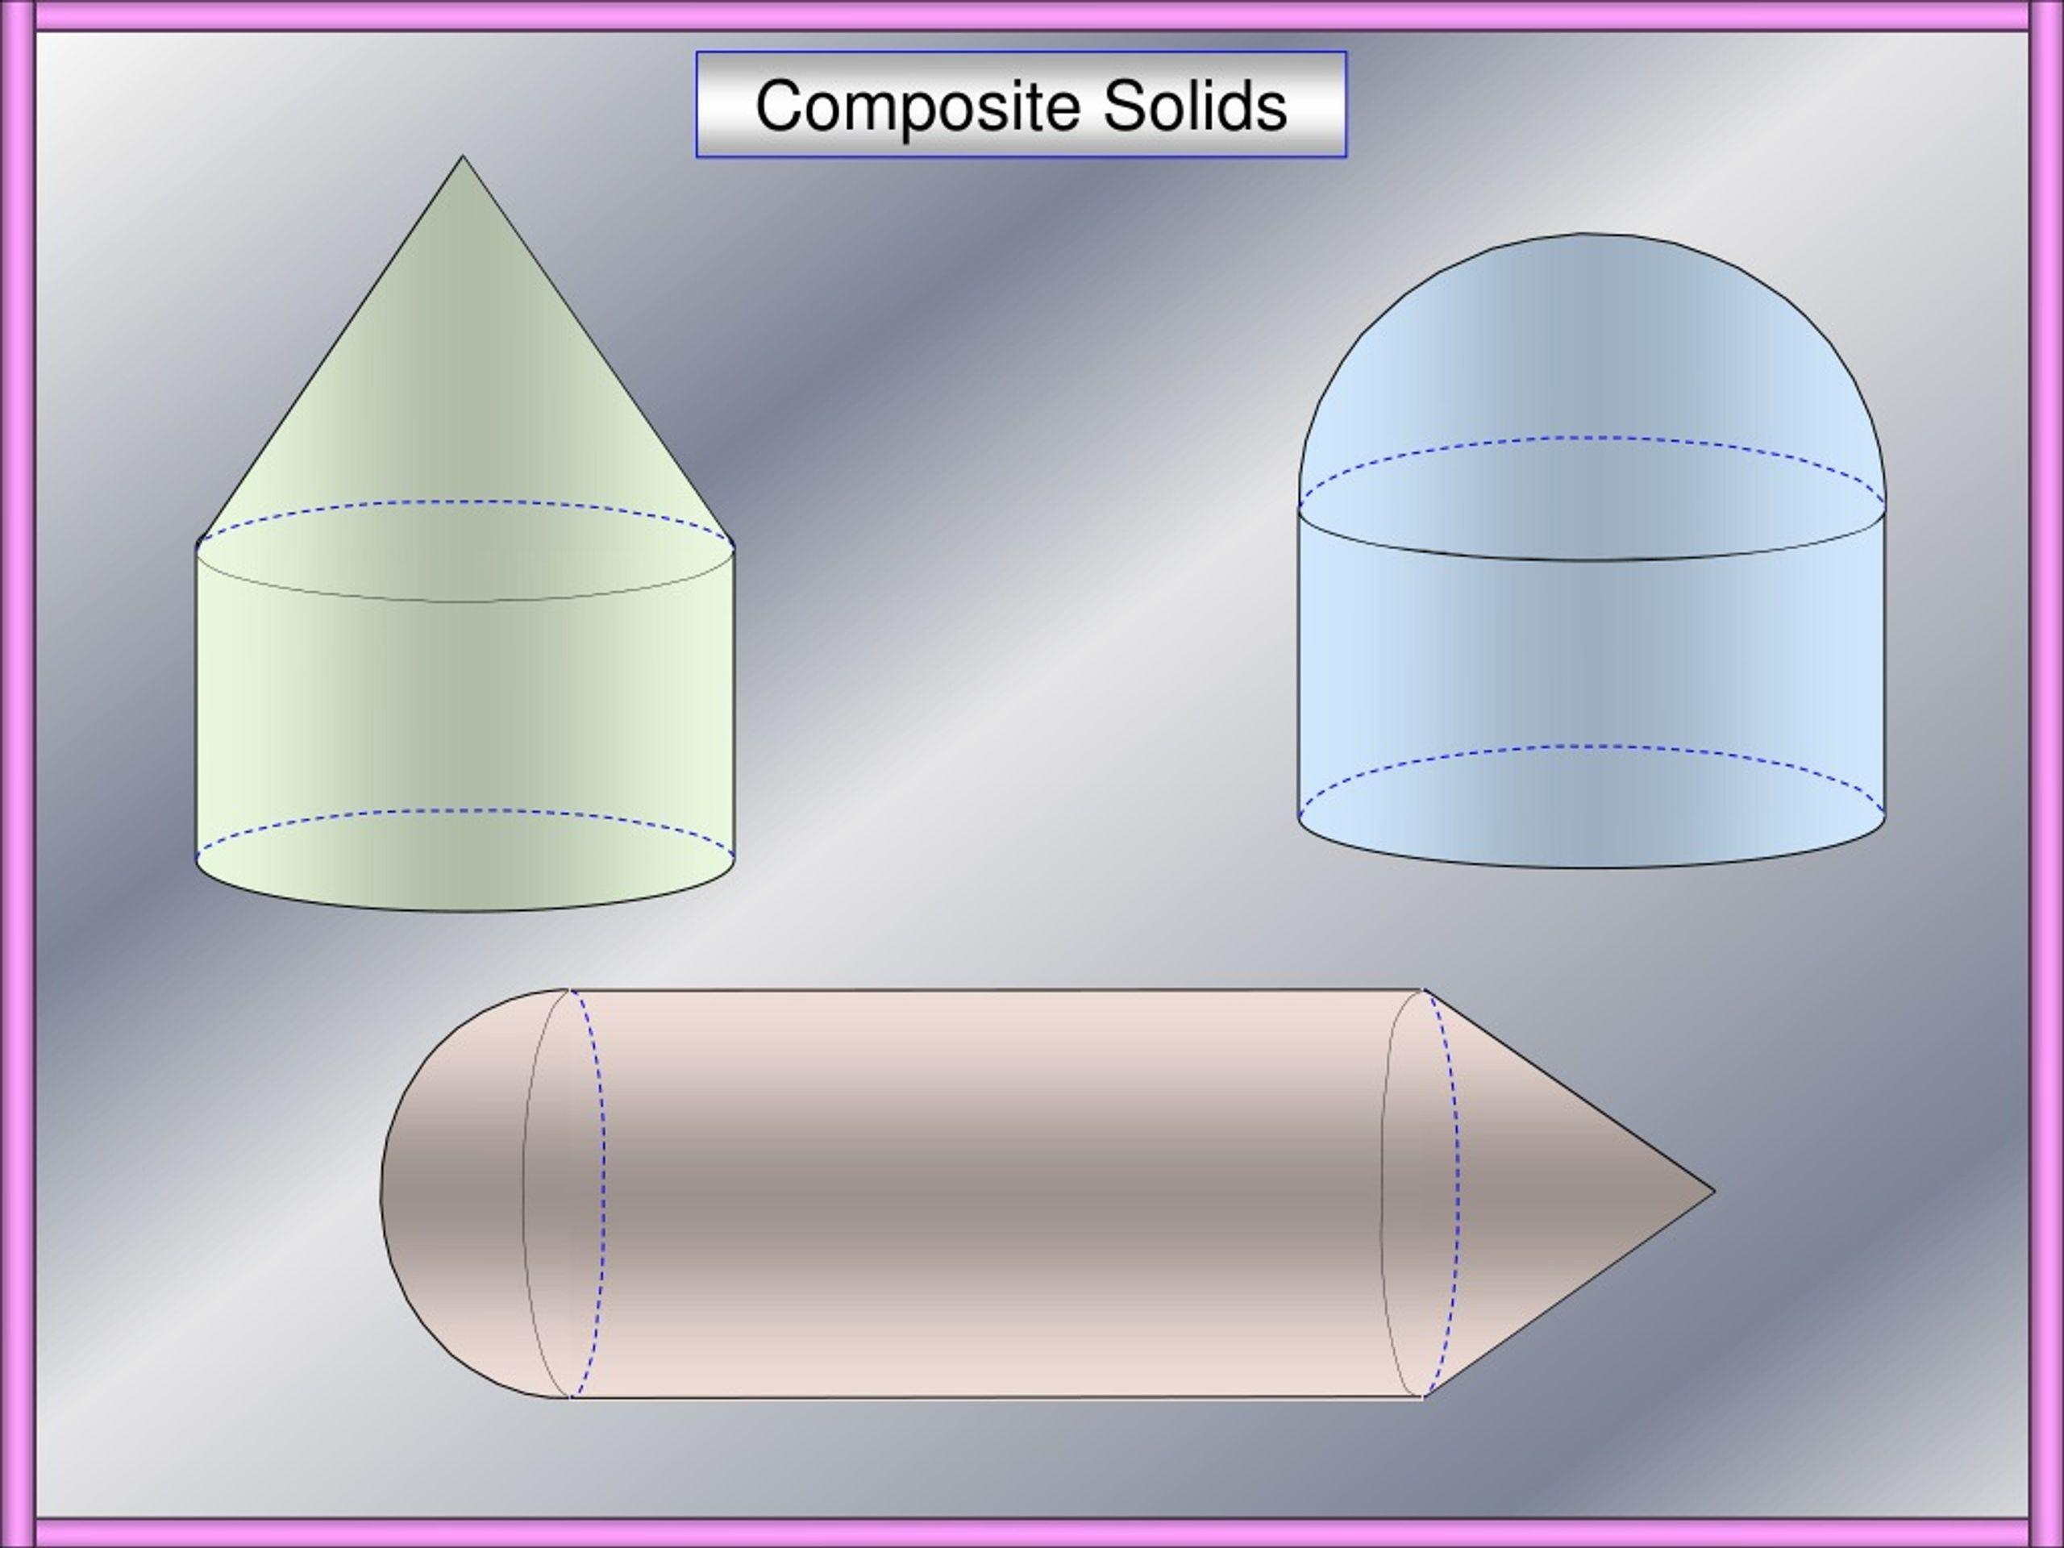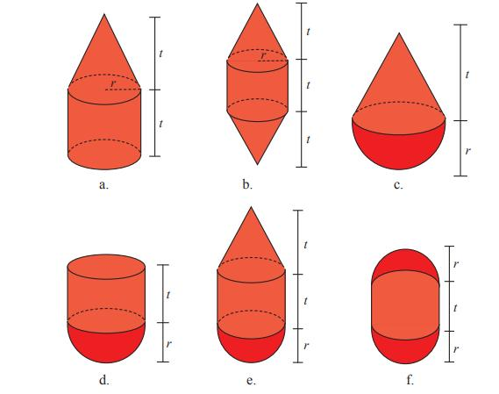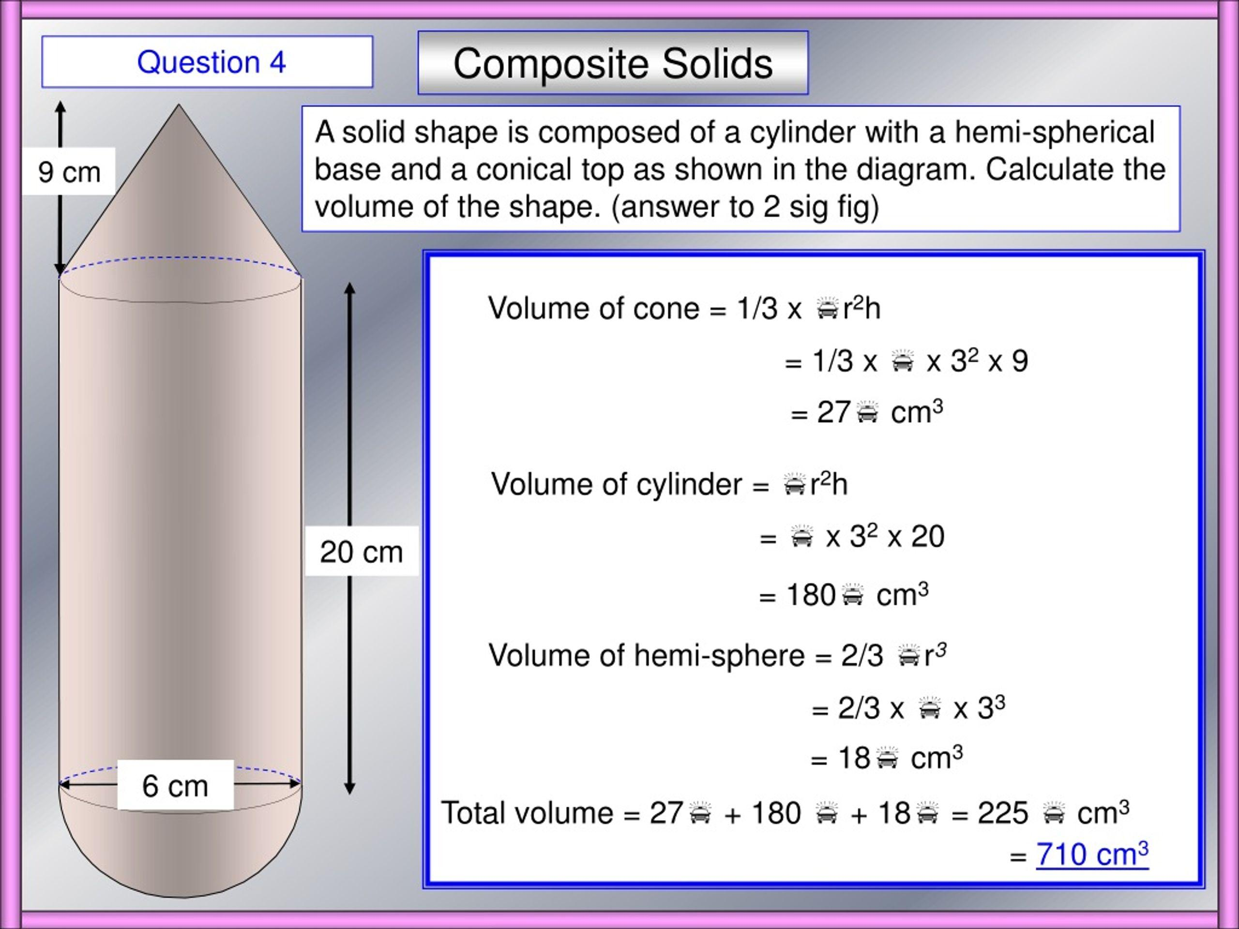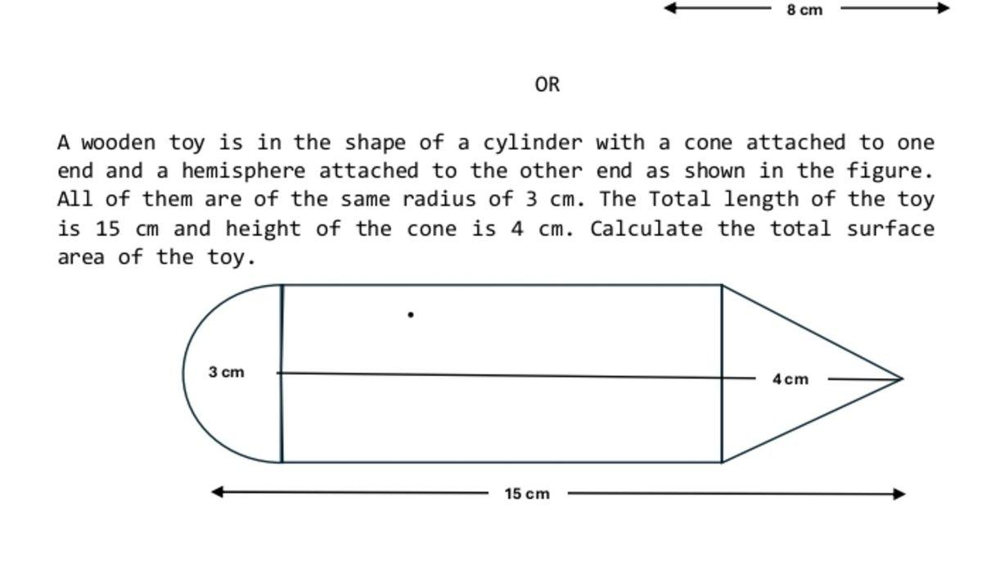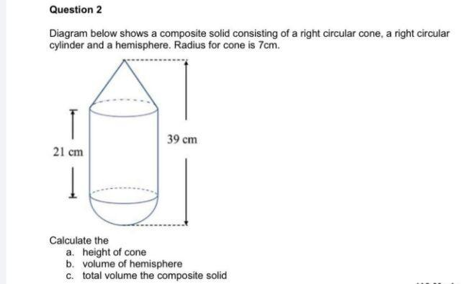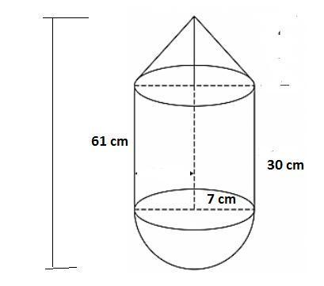
Formed by combining a cylinder with two or more different types of curved solids.
Examples:
- Cylinder with a cone and a hemisphere.
- Cylinder with a sphere and a cone.
- Cylinder with multiple hemispheres and a frustum.
- Cylinder with cones, spheres, and hemispheres.

Cylinder with Multiple Flat-and-Curved Solid Types
# Source: AI Source: Provided by: [Data Path: Persons Table -> ID Column: 1, Name_En Column: Motasem Essam] -> From: [ChatGPT] on [7/25/2026]
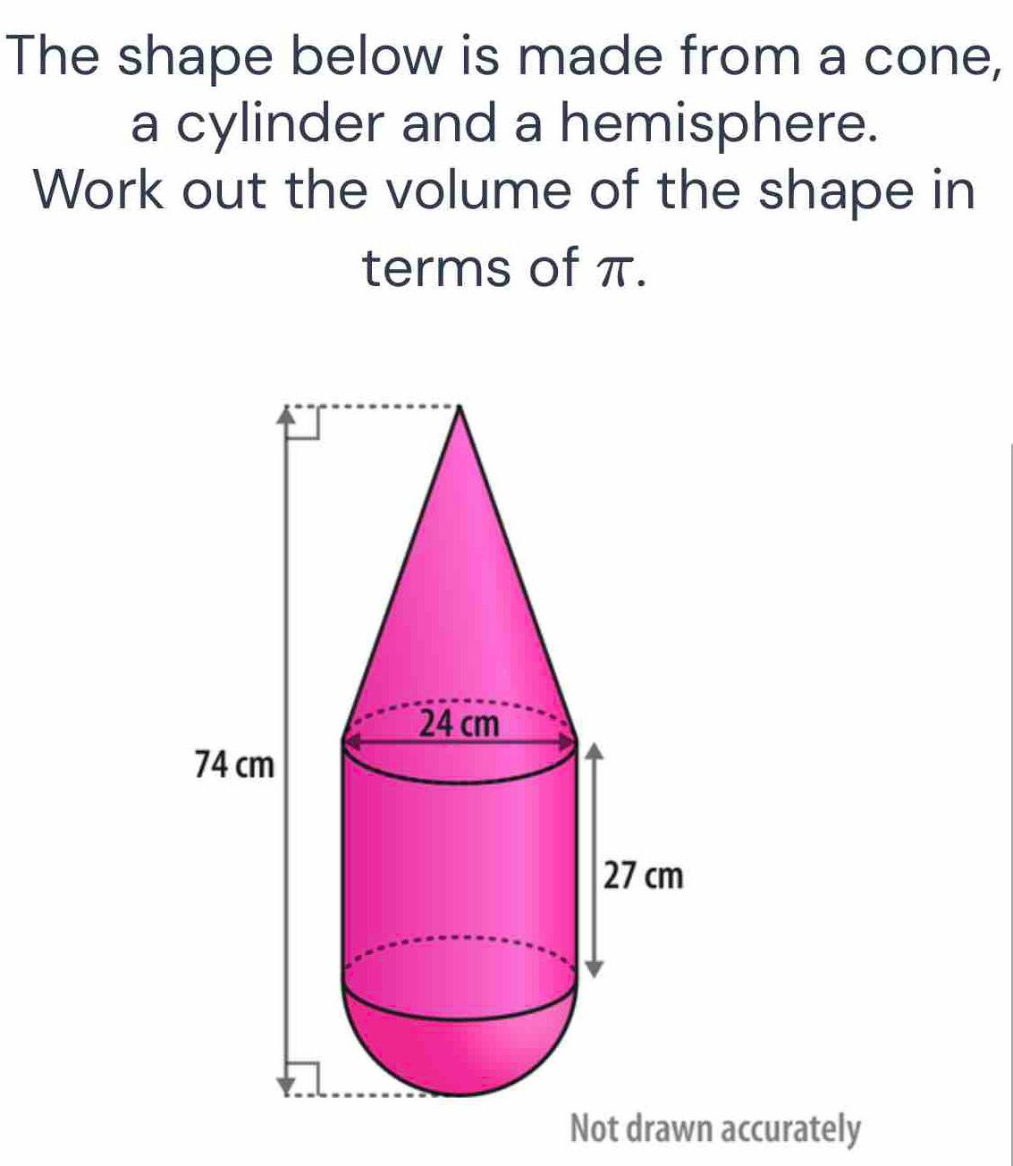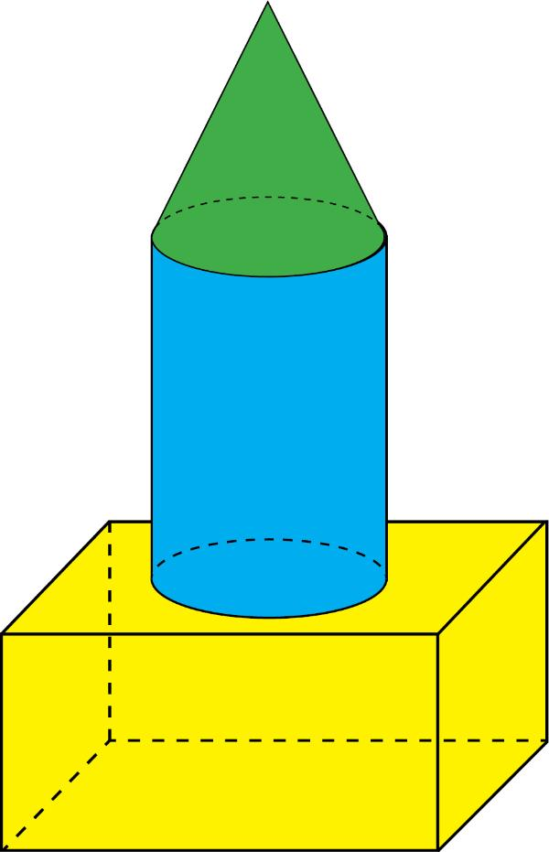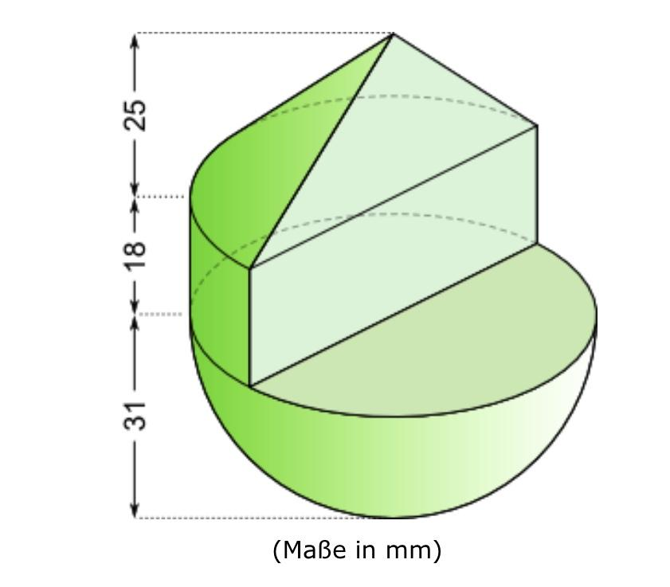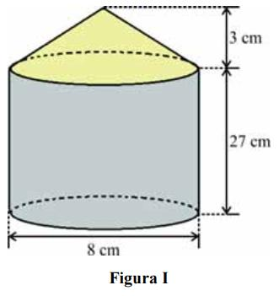
Formed by combining a cylinder with multiple solids that include both flat-faced and curved-surface components.
Examples:
- Cylinder with a rectangular prism and a cone.
- Cylinder with a prism and a hemisphere.
- Cylinder with a pyramid and a sphere.
- Cylinder with multiple prisms, cones, and hemispheres.

Classification by Cylinder Type
# Source: AI Source: Provided by: [Data Path: Persons Table -> ID Column: 1, Name_En Column: Motasem Essam] -> From: [ChatGPT] on [7/25/2026]
Cylinder-based composite solids can also be classified according to the type of cylinder used.
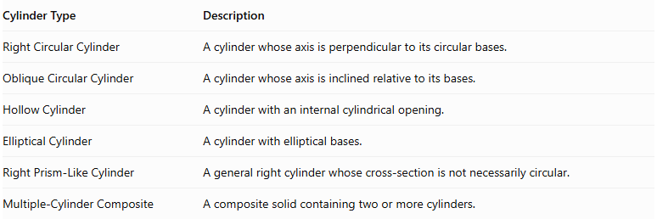
Cylinder Type | Description
Right Circular Cylinder | A cylinder whose axis is perpendicular to its circular bases.
Oblique Circular Cylinder | A cylinder whose axis is inclined relative to its bases.
Hollow Cylinder | A cylinder with an internal cylindrical opening.
Elliptical Cylinder | A cylinder with elliptical bases.
Right Prism-Like Cylinder | A general right cylinder whose cross-section is not necessarily circular.
Multiple-Cylinder Composite | A composite solid containing two or more cylinders.
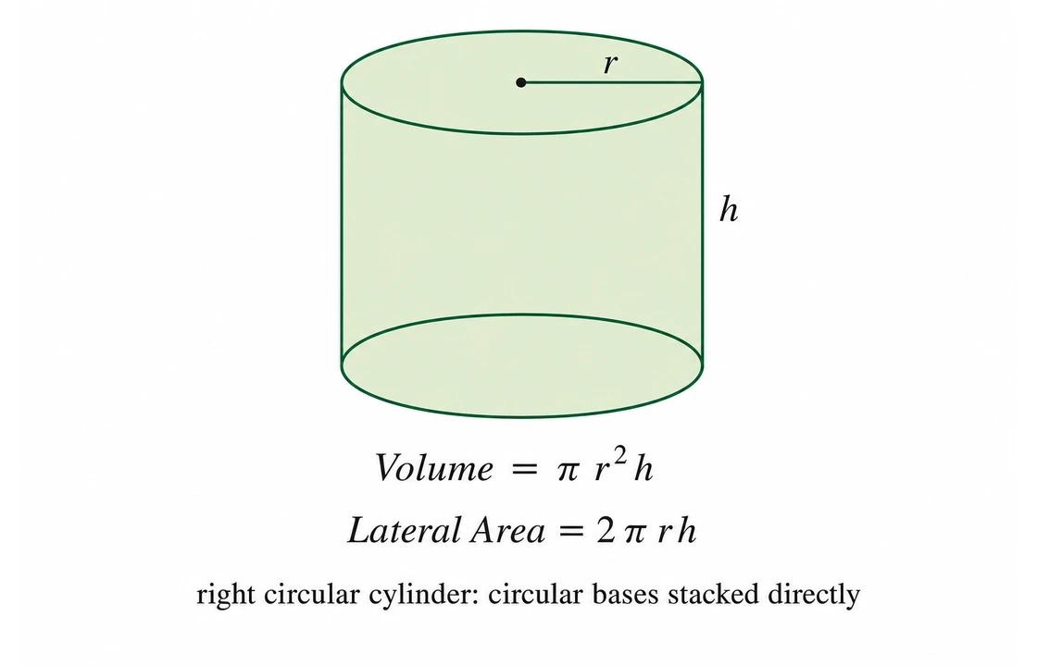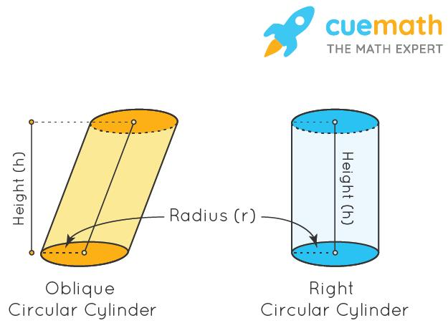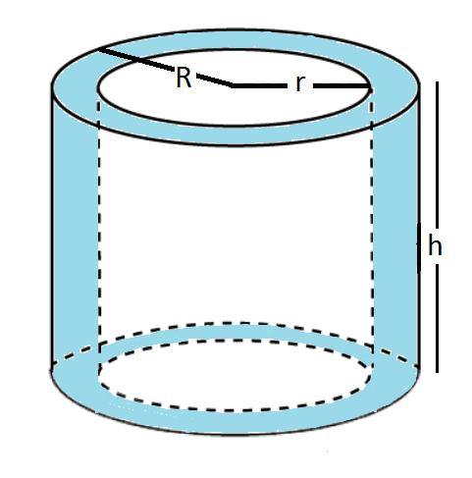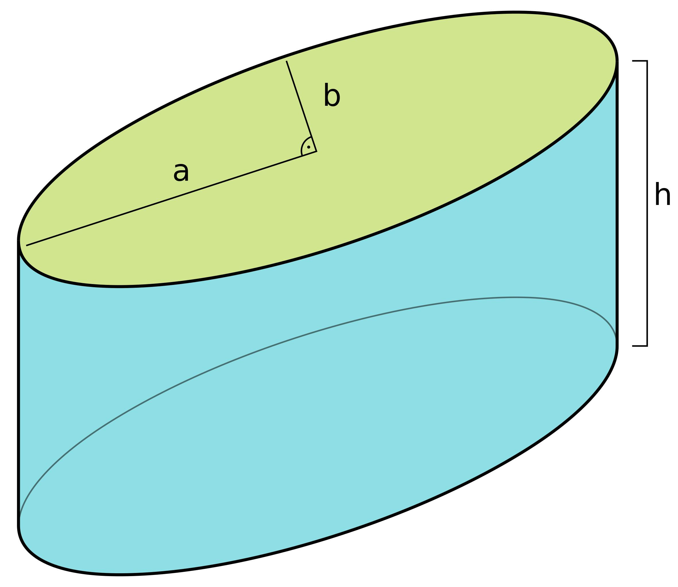

Classification by Arrangement
# Source: AI Source: Provided by: [Data Path: Persons Table -> ID Column: 1, Name_En Column: Motasem Essam] -> From: [ChatGPT] on [7/25/2026]
The components of a cylinder-based composite solid can be arranged in different ways.
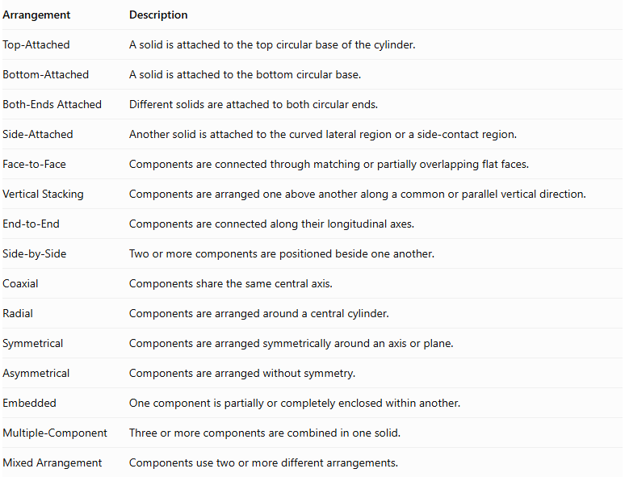
Arrangement | Description
Top-Attached | A solid is attached to the top circular base of the cylinder.
Bottom-Attached | A solid is attached to the bottom circular base.
Both-Ends Attached | Different solids are attached to both circular ends.
Side-Attached | Another solid is attached to the curved lateral region or a side-contact region.
Face-to-Face | Components are connected through matching or partially overlapping flat faces.
Vertical Stacking | Components are arranged one above another along a common or parallel vertical direction.
End-to-End | Components are connected along their longitudinal axes.
Side-by-Side | Two or more components are positioned beside one another.
Coaxial | Components share the same central axis.
Radial | Components are arranged around a central cylinder.
Symmetrical | Components are arranged symmetrically around an axis or plane.
Asymmetrical | Components are arranged without symmetry.
Embedded | One component is partially or completely enclosed within another.
Multiple-Component | Three or more components are combined in one solid.
Mixed Arrangement | Components use two or more different arrangements.
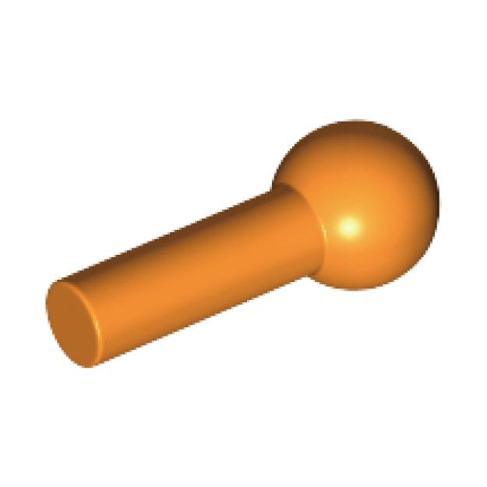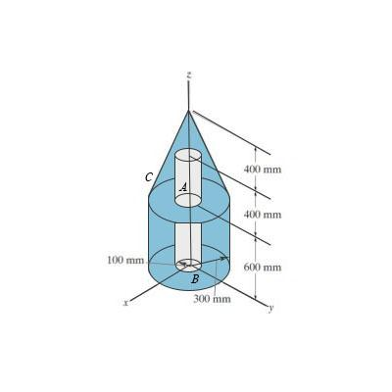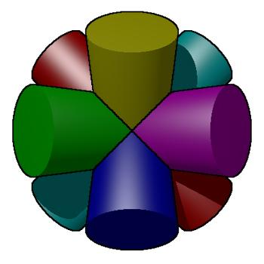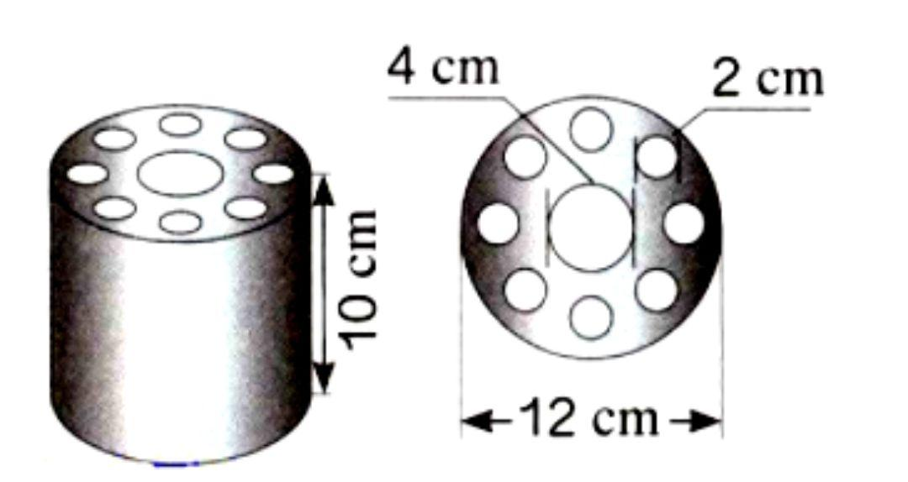

Classification by Surface Combination
# Source: AI Source: Provided by: [Data Path: Persons Table -> ID Column: 1, Name_En Column: Motasem Essam] -> From: [ChatGPT] on [7/25/2026]
Cylinder-based composite solids can be classified according to the types of external surfaces they contain.
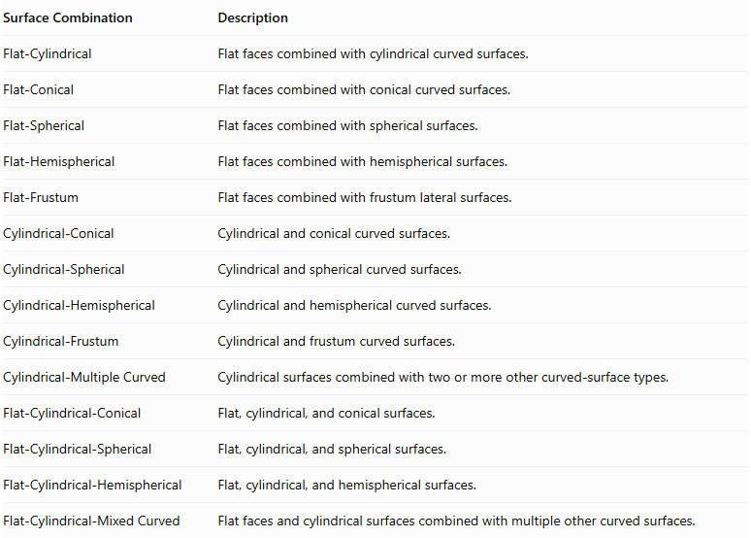
Surface Combination | Description
Flat-Cylindrical | Flat faces combined with cylindrical curved surfaces.
Flat-Conical | Flat faces combined with conical curved surfaces.
Flat-Spherical | Flat faces combined with spherical surfaces.
Flat-Hemispherical | Flat faces combined with hemispherical surfaces.
Flat-Frustum | Flat faces combined with frustum lateral surfaces.
Cylindrical-Conical | Cylindrical and conical curved surfaces.
Cylindrical-Spherical | Cylindrical and spherical curved surfaces.
Cylindrical-Hemispherical | Cylindrical and hemispherical curved surfaces.
Cylindrical-Frustum | Cylindrical and frustum curved surfaces.
Cylindrical-Multiple Curved | Cylindrical surfaces combined with two or more other curved-surface types.
Flat-Cylindrical-Conical | Flat, cylindrical, and conical surfaces.
Flat-Cylindrical-Spherical | Flat, cylindrical, and spherical surfaces.
Flat-Cylindrical-Hemispherical | Flat, cylindrical, and hemispherical surfaces.
Flat-Cylindrical-Mixed Curved | Flat faces and cylindrical surfaces combined with multiple other curved surfaces.

Mathematical Properties and Formulas

Volume
# Source: AI Source: Provided by: [Data Path: Persons Table -> ID Column: 1, Name_En Column: Motasem Essam] -> From: [ChatGPT] on [7/25/2026]
The total volume is calculated by adding the volumes of the components when they are joined without overlapping interiors.
$$V_{total}=V_{1}+V_{2}+⋯+V_{n}$$
If components overlap, their intersection volumes must be subtracted to avoid double-counting.
Important volume formulas:
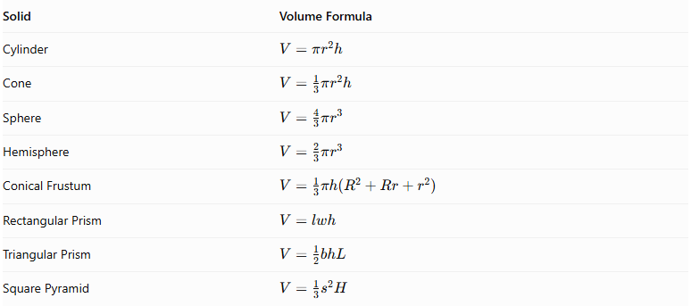
Solid | Volume Formula
Cylinder | $$V=πr^{2}h$$
Cone | $$V=\frac{1}{3}πr^{2}h$$
Sphere | $$V=\frac{4}{3}πr^{3}$$
Hemisphere | $$V=\frac{2}{3}πr^{3}$$
Conical Frustum | $$V=\frac{1}{3}πh(R^{2}+Rr+r^{2})$$
Rectangular Prism | $$V=lwh$$
Triangular Prism | $$V=\frac{1}{2}bhL$$
Square Pyramid | $$V=\frac{1}{3}s^{2}H$$
Where:
- $r$ = radius.
- $R$ = larger radius.
- $h$ = perpendicular height of a component.
- $H$ = perpendicular height of a pyramid or other specified solid.
- $l$ = length of a prism.
- $w$ = width.
- $b$ = base width of a triangle.
- $L$ = length of a triangular prism.

Surface Area
# Source: AI Source: Provided by: [Data Path: Persons Table -> ID Column: 1, Name_En Column: Motasem Essam] -> From: [ChatGPT] on [7/25/2026]
The external surface area is the sum of the exposed surfaces only. Joining regions that become internal are not included.
For two components joined through a complete matching planar face:
$${SA}_{external}={SA}_{1}+{SA}_{2}-2A_{joining}$$
For partial contact, subtract the actual hidden contact regions from the exposed surfaces of the components. For curved or intersecting joins, calculate the resulting external boundary directly.
Important surface-area formulas:
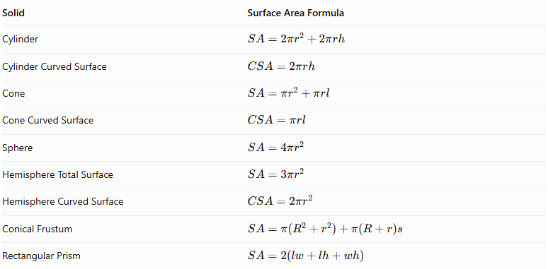
Solid | Surface Area Formula
Cylinder | $$SA=2πr^{2}+2πrh$$
Cylinder Curved Surface | $$CSA=2πrh$$
Cone | $$SA=πr^{2}+πrl$$
Cone Curved Surface | $$CSA=πrl$$
Sphere | $$SA=4πr^{2}$$
Hemisphere Total Surface | $$SA=3πr^{2}$$
Hemisphere Curved Surface | $$CSA=2πr^{2}$$
Conical Frustum | $$SA=π(R^{2}+r^{2})+π(R+r)s$$
Rectangular Prism | $$SA=2(lw+lh+wh)$$
For a right circular cone:
$$l=\sqrt{r^{2}+h^{2}}$$
For a right circular conical frustum:
$$s=\sqrt{h^{2}+(R-r)^{2}}$$
Here, $l$ and $s$ represent slant heights.

Important Surface-Area Considerations
# Source: AI Source: Provided by: [Data Path: Persons Table -> ID Column: 1, Name_En Column: Motasem Essam] -> From: [ChatGPT] on [7/25/2026]
- A cylinder's circular base becomes hidden when another solid completely covers it.
- A cone attached to a cylinder through its circular base hides the joining disk.
- A hemisphere attached through its flat circular face hides that face.
- A sphere touching a cylinder at a single point does not create a joining surface with positive area.
- A component attached to a cylinder's curved lateral surface may have a curved or partial contact region; its hidden area must be calculated according to the actual geometry.
- A surface that remains exposed must be counted even if it belongs to a component that is partly hidden.

Worked Examples

Example 1: Cylinder with a Cone on Top
# Source: AI Source: Provided by: [Data Path: Persons Table -> ID Column: 1, Name_En Column: Motasem Essam] -> From: [ChatGPT] on [7/25/2026]
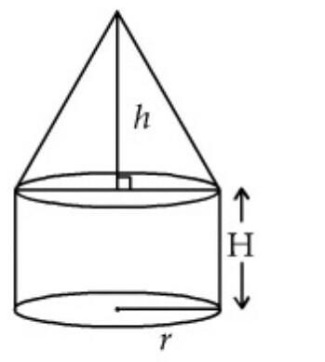
Given:
A cylinder has:
- Radius = 3 cm.
- Height = 8 cm.
A cone is attached to its top circular base:
- Radius = 3 cm.
- Height = 4 cm.
Find the total volume and external surface area.
Step 1: Calculate the cylinder volume.
$$V_{c}=πr^{2}h$$
$$V_{c}=π(3)^{2}(8)=72π$$
Step 2: Calculate the cone volume.
$$V_{cone}=\frac{1}{3}πr^{2}h$$
$$V_{cone}=\frac{1}{3}π(3)^{2}(4)=12π$$
Step 3: Calculate the total volume.
$$V_{total}=72π+12π$$
$$\boxed{V_{total}=84π≈263.89{ cm}^{3}}$$
Step 4: Calculate the cylinder's exposed surface area.
The cylinder's top circular base is hidden by the cone. Its exposed area consists of the curved surface and bottom base.
$${SA}_{c}=2πrh+πr^{2}$$
$${SA}_{c}=2π(3)(8)+π(3)^{2}$$
$${SA}_{c}=57π$$
Step 5: Calculate the cone's curved surface area.
First, calculate its slant height:
$$l=\sqrt{r^{2}+h^{2}}$$
$$l=\sqrt{3^{2}+4^{2}}=5$$
Then:
$${CSA}_{cone}=πrl$$
$${CSA}_{cone}=π(3)(5)=15π$$
Step 6: Calculate the external surface area.
$${SA}_{total}=57π+15π$$
$$\boxed{{SA}_{total}=72π≈226.19{ cm}^{2}}$$
<badge color="success">Final Answer</badge>
- Total Volume = $84π≈263.89{ cm}^{3}$
- External Surface Area = $72π≈226.19{ cm}^{2}$

Example 2: Cylinder with Hemispherical Ends
# Source: AI Source: Provided by: [Data Path: Persons Table -> ID Column: 1, Name_En Column: Motasem Essam] -> From: [ChatGPT] on [7/25/2026]
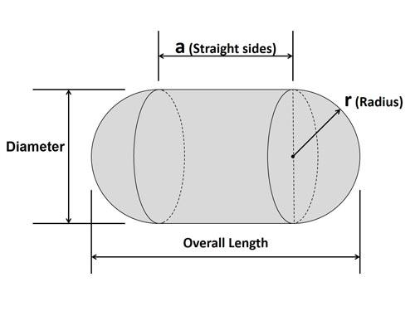
Given:
A composite solid consists of a cylinder with a hemisphere attached to each end.
- Cylinder radius = 2 cm.
- Cylinder length = 6 cm.
- Each hemisphere radius = 2 cm.
Find the total volume and external surface area.
Step 1: Calculate the cylinder volume.
$$V_{c}=πr^{2}h$$
$$V_{c}=π(2)^{2}(6)=24π$$
Step 2: Calculate the volume of the two hemispheres.
Two hemispheres form one complete sphere.
$$V_{s}=\frac{4}{3}πr^{3}$$
$$V_{s}=\frac{4}{3}π(2)^{3}=\frac{32π}{3}$$
Step 3: Calculate the total volume.
$$V_{total}=24π+\frac{32π}{3}$$
$$\boxed{V_{total}=\frac{104π}{3}≈108.91{ cm}^{3}}$$
Step 4: Calculate the cylinder's curved surface area.
The two circular cylinder ends are hidden by the hemispheres.
$${CSA}_{c}=2πrh$$
$${CSA}_{c}=2π(2)(6)=24π$$
Step 5: Calculate the curved surface area of the two hemispheres.
$${CSA}_{two hemispheres}=4πr^{2}$$
$$=4π(2)^{2}=16π$$
Step 6: Calculate the external surface area.
$${SA}_{total}=24π+16π$$
$$\boxed{{SA}_{total}=40π≈125.66{ cm}^{2}}$$
<badge color="success">Final Answer</badge>
- Total Volume = $\frac{104π}{3}≈108.91{ cm}^{3}$
- External Surface Area = $40π≈125.66{ cm}^{2}$

Important Characteristics
# Source: AI Source: Provided by: [Data Path: Persons Table -> ID Column: 1, Name_En Column: Motasem Essam] -> From: [ChatGPT] on [7/25/2026]
- Cylindrical Component: Every solid in this category contains at least one cylinder.
- Mixed Surfaces: The external boundary can contain flat, cylindrical, conical, spherical, and other curved surfaces.
- Multiple Components: A composite solid may contain two or more geometric components.
- Different Arrangements: Components can be attached vertically, horizontally, radially, or asymmetrically.
- Hidden Joining Surfaces: Contact regions become internal and must be excluded from external surface-area calculations.
- Volume Combination: Component volumes can be added when their interiors do not overlap.
- Complex External Boundaries: The resulting solid may have a more complicated shape than any individual component.
- Symmetry: Some cylinder-based composite solids have rotational symmetry or reflection symmetry.
- Different Dimensions: Components may have equal or different radii, heights, lengths, and base dimensions.
- Flat and Curved Connections: Components may connect through complete planar faces, partial planar regions, or curved contact regions.

Comparison with Other Composite Solids with Flat and Curved Surfaces
# Source: AI Source: Provided by: [Data Path: Persons Table -> ID Column: 1, Name_En Column: Motasem Essam] -> From: [ChatGPT] on [7/25/2026]
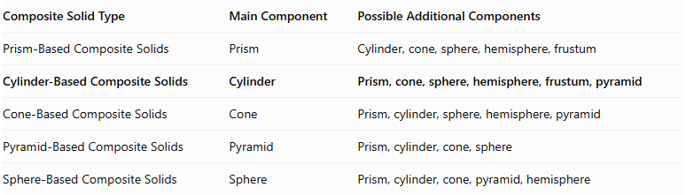
Composite Solid Type | Main Component | Possible Additional Components
Prism-Based Composite Solids | Prism | Cylinder, cone, sphere, hemisphere, frustum
Cylinder-Based Composite Solids | Cylinder | Prism, cone, sphere, hemisphere, frustum, pyramid
Cone-Based Composite Solids | Cone | Prism, cylinder, sphere, hemisphere, pyramid
Pyramid-Based Composite Solids | Pyramid | Prism, cylinder, cone, sphere
Sphere-Based Composite Solids | Sphere | Prism, cylinder, cone, pyramid, hemisphere

Applications
# Source: AI Source: Provided by: [Data Path: Persons Table -> ID Column: 1, Name_En Column: Motasem Essam] -> From: [ChatGPT] on [7/25/2026]
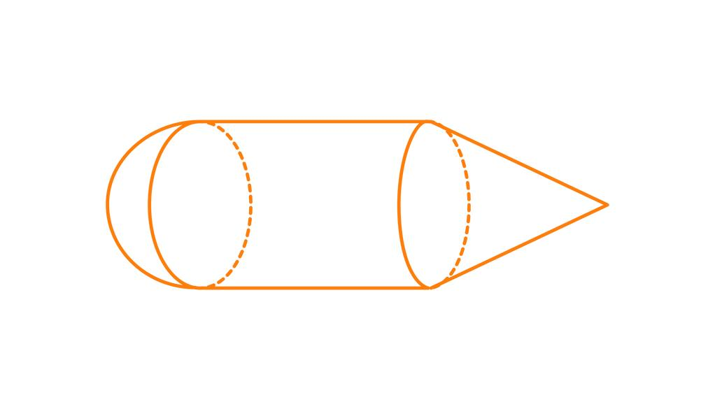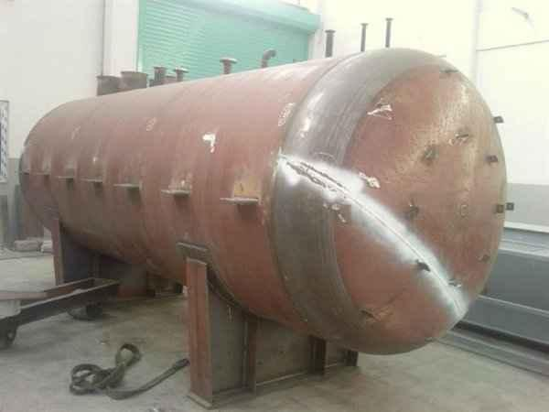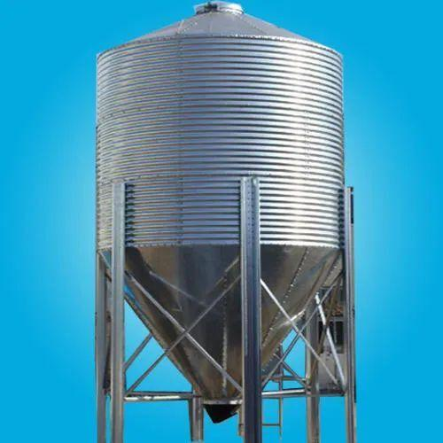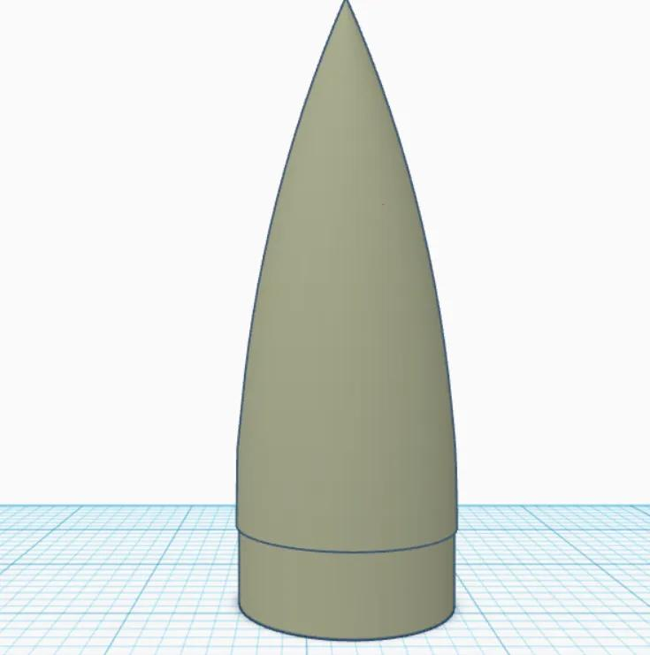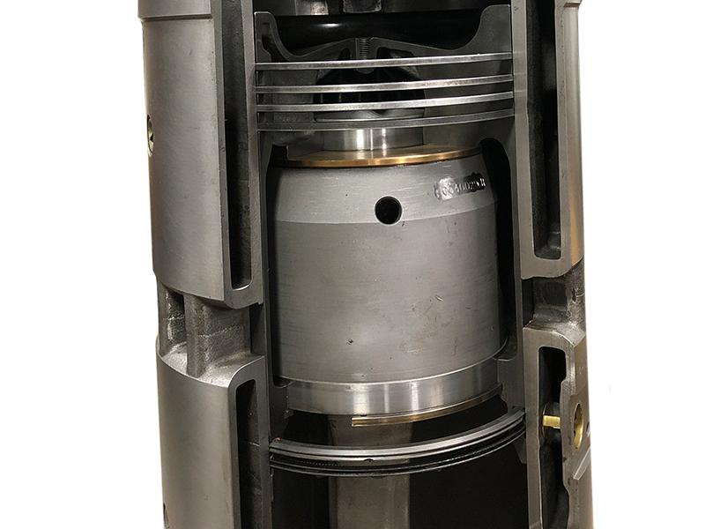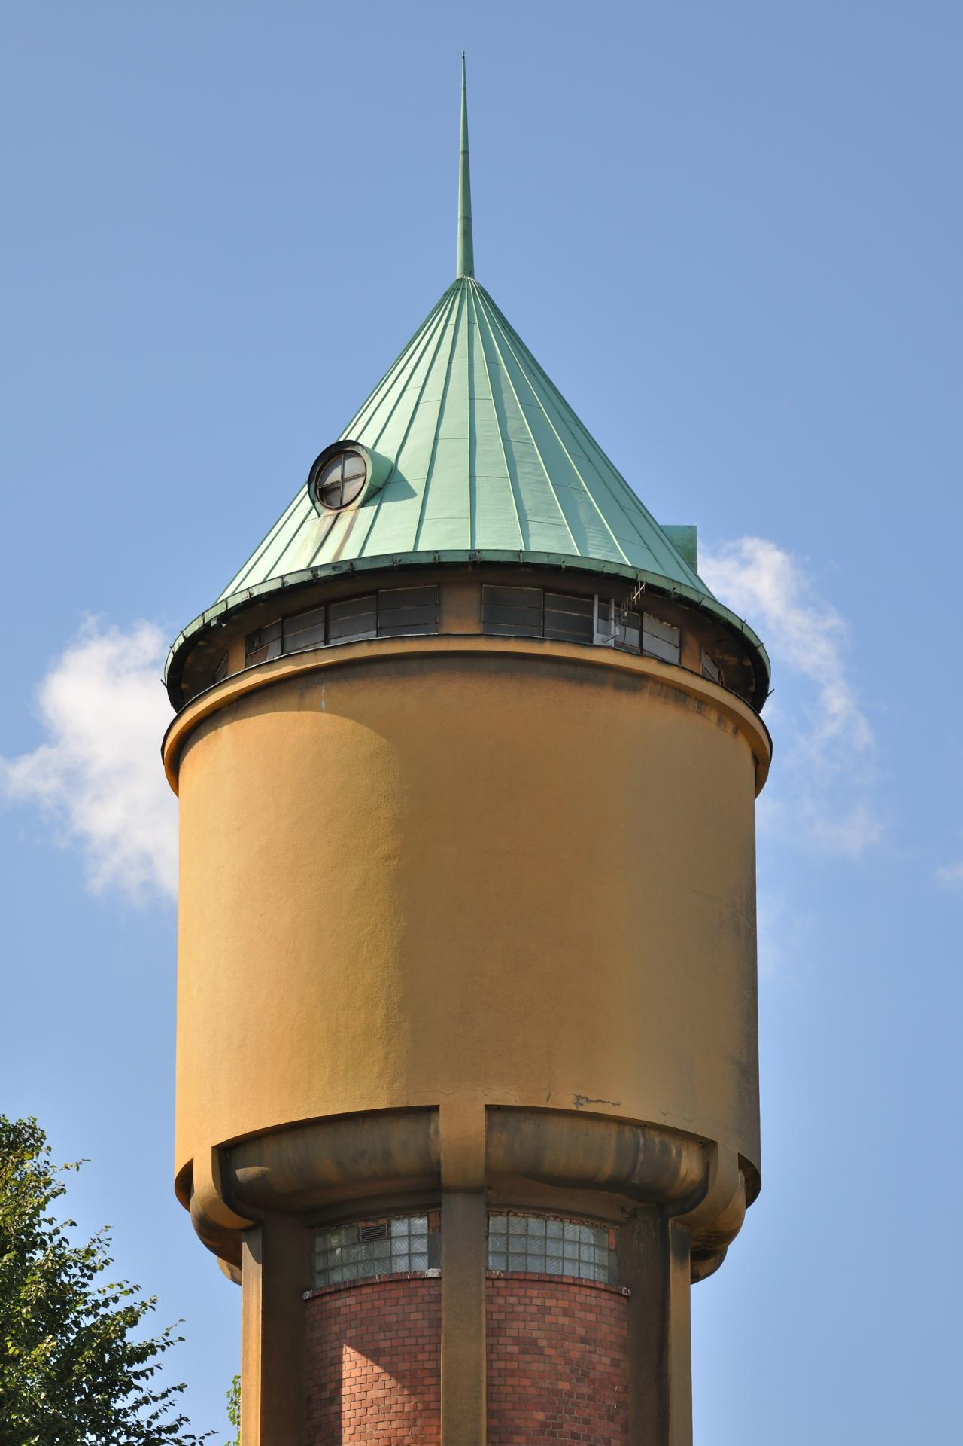
Cylinder-based composite solids are commonly found in:
- Architecture: Towers, columns, decorative structures, and building components.
- Mechanical Engineering: Pistons, pressure vessels, shafts, and machine components.
- Manufacturing: Tanks, containers, pipes, and industrial equipment.
- Automotive Engineering: Engine components, cylindrical housings, and mechanical assemblies.
- Aerospace Engineering: Rocket bodies, fuel tanks, and cylindrical structures with conical or rounded ends.
- Construction: Water tanks, support columns, silos, and storage structures.
- Product Design: Bottles, containers, lamps, and household products.
- Industrial Design: Equipment housings, pressure containers, and specialized machinery.
- Computer-Aided Design (CAD): Modeling complex three-dimensional objects from multiple geometric components.

Key Points
# Source: AI Source: Provided by: [Data Path: Persons Table -> ID Column: 1, Name_En Column: Motasem Essam] -> From: [ChatGPT] on [7/25/2026]
- Cylinder-based composite solids contain at least one cylindrical component.
- They can combine cylinders with prisms, cones, spheres, hemispheres, frustums, and pyramids.
- Their external surfaces may include both flat and curved regions.
- Their volume is calculated by combining component volumes while accounting for overlaps.
- Their external surface area includes only exposed surfaces.
- Joining surfaces that become internal must not be counted.
- The arrangement and dimensions of the components determine the resulting geometry.

Conclusion
# Source: AI Source: Provided by: [Data Path: Persons Table -> ID Column: 1, Name_En Column: Motasem Essam] -> From: [ChatGPT] on [7/25/2026]
Cylinder-Based Composite Solids are an important category of composite geometric solids formed by combining cylinders with other flat-faced or curved-surface solids. They can produce a wide variety of three-dimensional structures with different arrangements, dimensions, and surface combinations.
Understanding their components, classifications, volume formulas, and external surface-area calculations provides a foundation for studying complex geometric objects and their practical applications in engineering, architecture, manufacturing, and design.

